Celebration of Greek Independence Day
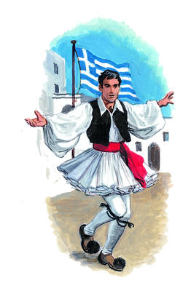
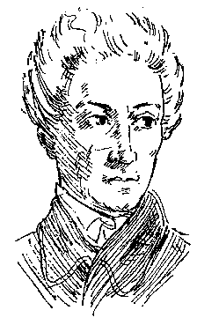
On Sunday, March 21, 2004, in celebration of Greek Independence Day, Hellenic Link–Midwest will present Maria Foustalieraki in “Highlights from Greek History - Poems and Songs from the Struggles for Freedom”. The program starts at 3 PM, at the Four Points Sheraton Hotel, 10255 West Irving Park Road, in Schiller Park, the corner of Irving Park and Mannheim Roads, by O’Hare airport. Phone number: 847 671 4230.
Dr. Foustalieraki will present poetry and perform songs from Greek folk culture and poems written by Rigas Feraios, Dionysios Solomos - the national poet of Greece, Nikos Gatsos, and others, set to the music of internationally acclaimed Greek composers Nikolaos Mantzaros, Yiannis Markopoulos, Manos Hadjidakis, and Christos Leontis, among others.
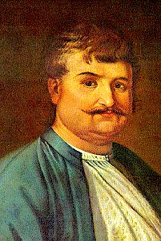
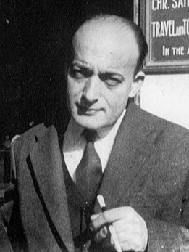
Dr. Foustalieraki was born in Thessaloniki, Greece to Cretan parents. She studied advanced music theory, music education, and piano at the Public Conservatory of Thessaloniki and holds a B.S. in Economics from the Aristotle University of Thessaloniki. After a year of musicology studies at same University, she came to the US in 1986 to pursue graduate studies in music education. She earned a Master’s degree and a Ph.D. in Music Education from Kent State University in Kent, Ohio, and an Orff-Schulwerk Certification from Hamline University, St. Paul, Minnesota. Maria has received scholarship awards for academic excellence from several organizations both in Greece and the USA.
Maria has extensive performing experience as a singer, pianist, and choir director in both Greece and the USA. In the Chicago area, she has been an active presenter of musical programs to the Greek and Greek-American Community (for the Hellenic Cultural Organization, the Hellenic Link, the Greek Orthodox Diocese of Chicago, and the Consulate General of Greece).
Get directions to the hotel and see our newsletters at www.helleniclinkmidwest.org

